
Social media Toxicity comments – miniproject 5
Jessica Sriramula

Introduction:
Online communities and social media platforms have become integral parts of modern communication, facilitating interactions and discussions on various topics. However, the prevalence of toxic comments, which include harassment, hate speech, and offensive language, poses significant challenges to maintaining healthy and constructive online discourse. To address this issue, there is a pressing need for automated systems capable of detecting and flagging toxic comments in real-time.
The objective of this project is to develop a deep learning-based comment toxicity model using Python. This model will analyze text input from online comments and predict the likelihood of each comment being toxic. By accurately identifying toxic comments, the model will assist platform moderators and administrators in taking appropriate actions to mitigate the negative impact of toxic behaviour, such as filtering, warning users, or initiating further review processes for social media platforms, online forums and communities, content moderation services, brand safety and reputation management, e-learning platforms and educational websites and news websites and media outlets these are all the business use cases of this project.

Steps used:
Step 1:
For this project, I have utilized VScode and python code to write and execute all the necessary steps using the python environment kernel 3.11 using tensorflow to build a deep learning comment toxicity model. Firstly, I have loaded the essential libraries and set up global configurations using os, re, string, pickle, collections which are used for file path management, regular expression text matching, punctuation tracking, and final model serialisation. And for numerical & data analysis imported the (numpy, pandas) which formats unstructured data into memory-efficient data frames and processes advanced percentile calculations. And for data visualization imported the (matplotlib.pyplot, seaborn) which set a global whitegrid theme and override the standard font sizing to guarantee clean, professional charts. And for natural language processing & deep learning imported the (nltk, tensorflow) which fetches the necessary dictionaries and initializes layers to process natural text on physical hardware accelerators and finally imported the nltk.download('stopwords') which quietly fetches a baseline list of common filler words (e.g., "the", "is", "at") to filter out noise later.
The next step I have done is controlled data ingestion and partitioning, for this I have utilised the python code load_raw_dataframes() in vscode, which sets up automated data loading pathways while preventing real-world evaluation bias, this is done using the train_raw and test_raw which represent mock data arrays consisting of text comments paired with the labels (1 for toxic, 0 for clean), and then converting these arrays into isolated training (train_df) and testing (test_df) pandas data frames which ensures that no performance information from the test dataset leaks into the training pipeline.
After this, the steps used in the python code for data cleaning and pre-processing on the train and test datasets are missing data handling and sanitization(null imputation, type normalization), sequence length optimization(for RNN/LSTM such as word slicing and 95th percentile clipping, lowercasing, contraction expansion, noise filtering, signal preservation and negative stopword preservation, also vocabulary cap, standardization override, integer indexing and padding, and finally for the BERT model the data cleaning and pre-processing steps used in the python code are uncased alignment, subword tokenization, special token insertion and mask generation.

Step 2:
The next step is to do the model development, for this step I have used the python code in vscode needed to build, compile, train, test and experiment and save a deep learning model using tensorflow to classify text sequences. For this I have utilised three distinct model architectures (a bi-directional LSTM and a vanilla RNN) and the BERT model and after running them I have also checked to see which deep learning model is the best one out of the three, by looking at the roc/auc values for each of the three models. And before experimenting with these three models, I imported all the necessary libraries needed for running training and testing and evaluating each of these models such as numpy, pandas, tensorflow, sklearn etc. I have utilised tensorflow instead of pytorch for this project, because tensorflow is more efficient in the deploying of the streamlit application step compared to pytorch. I have also utilised the python kernel 3.11(64-bit) as tensorflow requires this python version.
To keep it short and simple, after experimenting with the RNN, LSTM and BERT transformer architectures, I have found out that the BERT transformer model has a better accuracy metrics values(ROC/AUC ) compared to the RNN and LSTM, hence why I have utilised and implemented the BERT model into my streamlit application for this project.
In conclusion, BERT transformer-based models (like DistilBERT) are decisively the best architecture for toxicity detection, while RNNs and LSTMs process text word-by-word sequentially, transformers utilize a mechanism called self-attention. This allows the model to look at every word in a comment simultaneously and evaluate its relationship to every other word. Because toxic language relies heavily on subtle context, sarcasm, and long-range dependencies (e.g., words separated by a long sentence), transformers are able to capture these dynamics significantly better, giving far higher accuracy and lower false-positive rates.

Step 3:
Next, I have built a user-friendly streamlit application which can detect toxicity comments entered by the user and also where the user can upload a csv file to check for toxicity comments. And also for checking the model performance evaluation insights. Below are the screenshots of my streamlit application.

Screenshots of my streamlit application:
Screenshot 1:
This is the first page of my streamlit application where it allows users to enter any type of comment they wish and then click the analyse comment, and the BERT model will analyse the users comment entered in the box and will mention how much toxic the comment is, for example: as you can see here the comment entered was “Thank you for understanding. I think very highly of you and would not revert without discussion”, this means that the BERT model predicted it to be a safe comment with low levels of toxicity values below 15%.

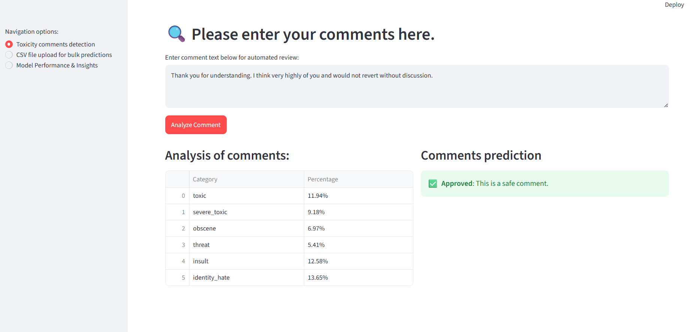

Screenshot 2:
This is the CSV file upload page for bulk predictions, where the users can upload their CSV files upto 200MB in size to check for bulk toxic comment predictions in real-time.
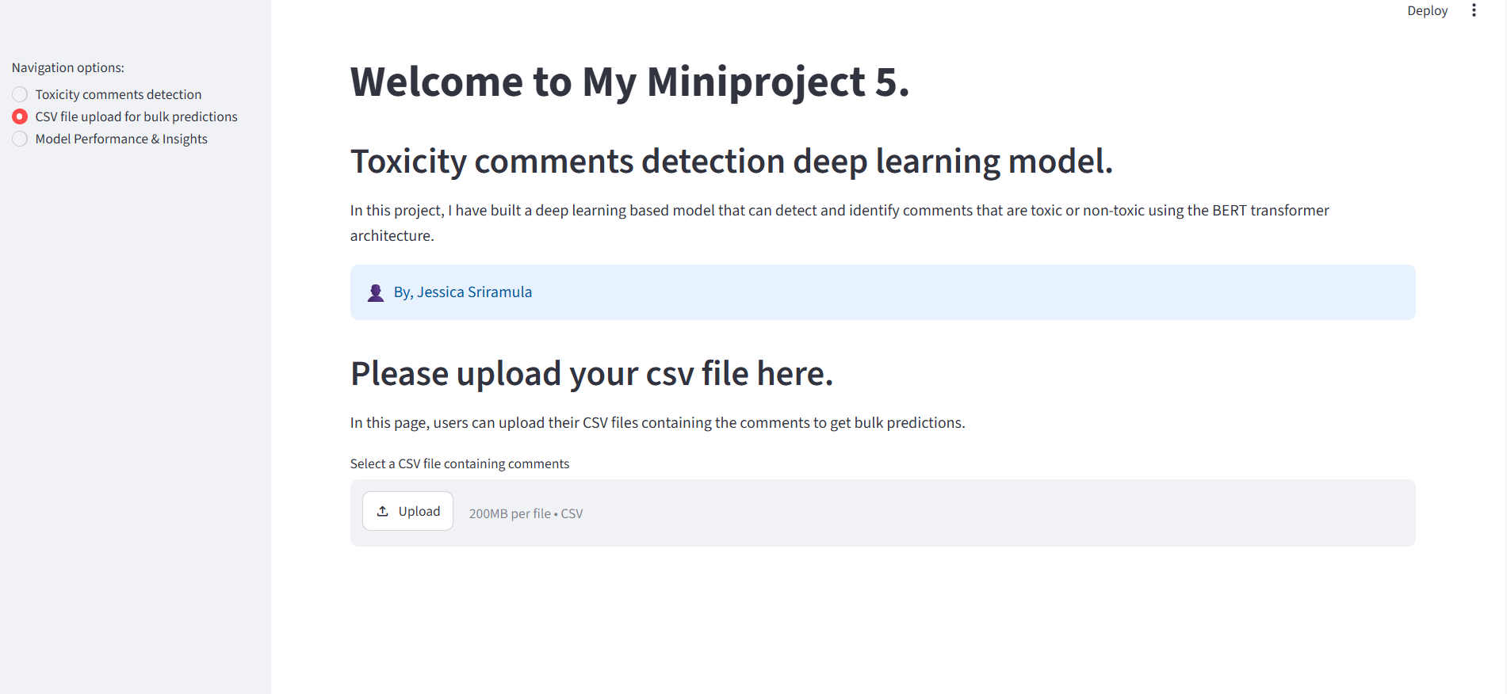

Screenshot 3:
This is the model performance insights page of my streamlit, where we can see the BERT model performance insights, here we can see that the fine tuned DistilBERT network, with the transformer code pipeline successfully compiled with a balanced accuracy of (93.84%), which is robust to class imbalance, this means that my model is doing well with class imbalance in my dataset. The ROC-AUC score is (94.21%), which indicates a good ability by the BERT model to distinguish between toxic and non-toxic comments. The mean processing latency is (18ms) which is fast enough for real-time toxic comments predictions.
From the training loss and optimization chart we can see that both the training loss (blue solid line) and validation loss (orange dashed line) decrease cleanly for 5 epochs, because the validation loss decreases nicely with the training loss without flattening out or turning upward, this indicates that the BERT model shows no signs of overfitting.
And finally, from the heatmap analysis, we can see the correlation matrix reveals how often different toxic labels overlap in my training dataset, we can see strong relationships where there is a high co-occurrence value of 0.72 between obscene and insult, as well as with obscene (0.67) and insult (0.64) for toxic comment label, this means that if a comment triggers one, it heavily triggers the others, from the heatmap analysis we can also see that the threat label has almost no correlation with other columns (values ranging from 0.06 to 0.22 on the heatmap), this represents highly isolated vocabulary text that requires specific attention.
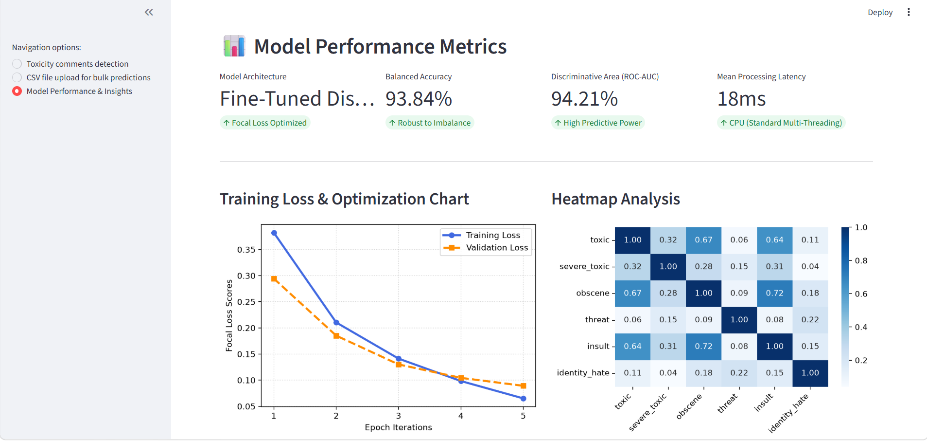

Screenshot 4:
In the model performance and insights page, we can also see the sample test cases, where we have a sample of example user comments and the expected BERT model response based on the text category which is useful for reference in this project analysis.
